BK7007 eBook Reader

User Manual

Safety Precautions
On Battery
- Charge the battery only in temperature that ranges
from 0 to 35 degree Celsius.
- Do not charge reader if the battery is found damaged
or leaking.
On Operation
- Never subject reader to extremes of light, temperature, moisture or vibration.
- Do not use or store reader in a location subject:
A. Extreme high temperature, such as in a sun-heated car
B. Direct sunlight
C. High humidity or places with corrosive substances
D. Sub-zero condition, especially during winter.
. On Micro SD/SDHC card
- After inserting a Micro SD/SDHC card, if the reader has no response, please take out and insert again.
- Do not remove Micro SD/SDHC card or turn off reader during data writing or reading to prevent damage to data and to the reader.
- Make sure the Micro SD/SDHC card is unlocked before writing or deleting data in the Micro SD/SDHC card.
- Backup your files and data before formatting the Micro SD/SDHC card. Please format the Micro SD/SDHC card in FAT.

Contents

Safety Precautions i
Contents ii
Chpater 1 BASICS 1
Parts and Control 1
Power On and Off the Reader 2
Charging the Reader 3
Importing contents 4
Importing DRM Contents 5
Home screen 8
Main Menu 10
Switching Screen orientation 12
Chpater 2 Getting started 13
Reading books 13
Playing Music 18
Watching Videos(optional) 19
Viewing photos 21
File Explorer 22
Chpater 3 settings 23
Language 23
Restore Defaults 23

Date & Time 23
Display Settings 23
Device Standby 23
About Product 24
Power Management 24
Calibrate Touch Screen 24
Screen Rotate 24
Vibration(optional) 24
Chpater 4 troubleshooting 25
Chpater 5 aPPENDIX 26
Maintenance 26
Product Specifications 26
Certification information 28
Copyrights and Trademark Notice 29
Disposal and Recycling Information 30
Disclaimer 30

Parts and Control
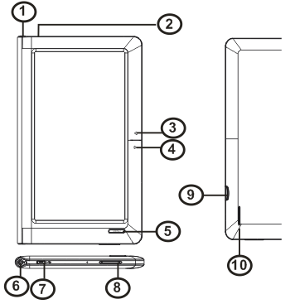
1. Power button – press and hold for 3 seconds to turn on/off. Press and hold for 6 seconds to restart.
2. Charging indicator
3,4. Page up/Page down button

5. Return button – press once to return to previous menu, press and hold to return to Main menu.
6. Earphone jack
7. Mini USB jack – for data transfer and emergency charging
8. VOL + /- button
9. Micro SD/SDHC card slot – supports Micro SD/SDHC card
10. Speaker

Power On and Off the Reader

Press and hold the [Power] button for 3 seconds to turn

on reader.

It may take a few moments for reader to turn on and

loading the content.
- If Reader does not turn on, charging is required.
- To turn off reader, press and hold [Power] button for 3
seconds.

Charging the Reader
- You need to charge the reader prior to using it for the first time or when battery power is low.
- Charge the reader using AC adapter with output 5V, 1.2A.
- Charging through PC may not be able to fully charge the reader due to the low output charging current from PC USB port.
- Please turn the reader to standby mode to shorten the charging process.
- It will take about 6 hours to fully charger the reader in standby mode (LCD off)
- When DC /USB power cable is connected to the reader for charging, the reader will enter into standby mode after remains idle for 60 s. Press the [Power] button to wake up the reader. The battery status is displayed at the bottom left corner.

Importing contents
From Computer
- The Reader supports USB Mass Storage Device function.
- To import contents (ebooks, video, audio, photo etc) into the reader, connect the reader to PC via the supplied USB cable.
- Upon successful connection to PC, the reader will enter USB mode and all operation will be halted.
- Go to [My Computer], double click on the reader’s disk to open.
- Perform the file management operation like USB device.

From memory card
This unit supports Micro SD/SDHC card up to 16GB
To insert a Memory card:
Insert the card correctly with the contact pin facing downwards as illustrated below. Pushing the card in, then you should hear a click when the reader is seated correctly. You may damage the card and the reader if Micro SD/SDHC card is not inserted correctly.
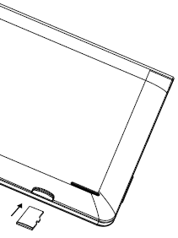

To remove Micro SD/SDHC card, push the card once again until it contact the back of the slot.
When the card is inserted or removed, it will take several seconds to load.
Please avoid inserting or ejecting the card when other operation is running as this may cause the system hang.
Do not remove the card if the content inside the card is being played. This will halt the operation of the reader and cause the reader to restart.

Importing DRM Contents
The Reader supports Adobe DRM contents. Adobe Digital Editions (ADE) is required.
Installing Adobe Digital Editions (ADE)
- The ADE installer is preloaded into the Reader.
- Connect the Reader to PC via the supplied USB cable and open the reader as removable disk. Go to [My Computer], double click on the reader’s disk to open.
- Make sure your computer is connected to internet
- Double click on the [digitaleditions_172] file to open the installer.
- Alternatively, you can download the installer from http://www.adobe.com/products/digitaleditions/#fp.
- For first time user, you will need to get a free adobe ID from adobe website. click on the [get an Adobe ID online] link as illustrated:

- Enter your email address and complete the online form as per instructed.
Authorizing PC and Reader
- Upon registration, return to the ADE window. Enter the user name and password to activate your Adobe account.
- After activation, connect the Reader to PC. ADE will detect the Reader and you are prompted to authorize device.
- After authorization, you will be able to find the Reader recognized in ADE as below. Contents inside the Reader will be displayed on the right hand windows.

- You can now start downloading or buying ebooks from online Ebook stores supporting Adobe DRM.
- Purchased or downloaded ebooks will be stored in [My Digital Editions] in [My Documents].

Transferring DRM ebooks to Reader
- From ADE menu, click on [All Items] on the left hand column.
- Items in [My Digital Editions] will be listed down in right window.
- Select the desired item(s) to be transferred, <Shift> + <Left click> to select multiple files.
- Drag and drop the selected item(s) into the Reader’s Drive located on the last row of the left side column as illustrated below.

Notes For using ADE
Each ADE ID supports only 6 devices, this includes the master device (the reader) and the slave device (Micro SD/SDHC card).
When the reader is restored to default settings, ALL DRM activation record and data (including DRM books purchased) will be erased from the reader. You are required to authorize the device with your ADE ID again.
When the number of authorized device has exceeded the allowable amount, you will come across the following error message:

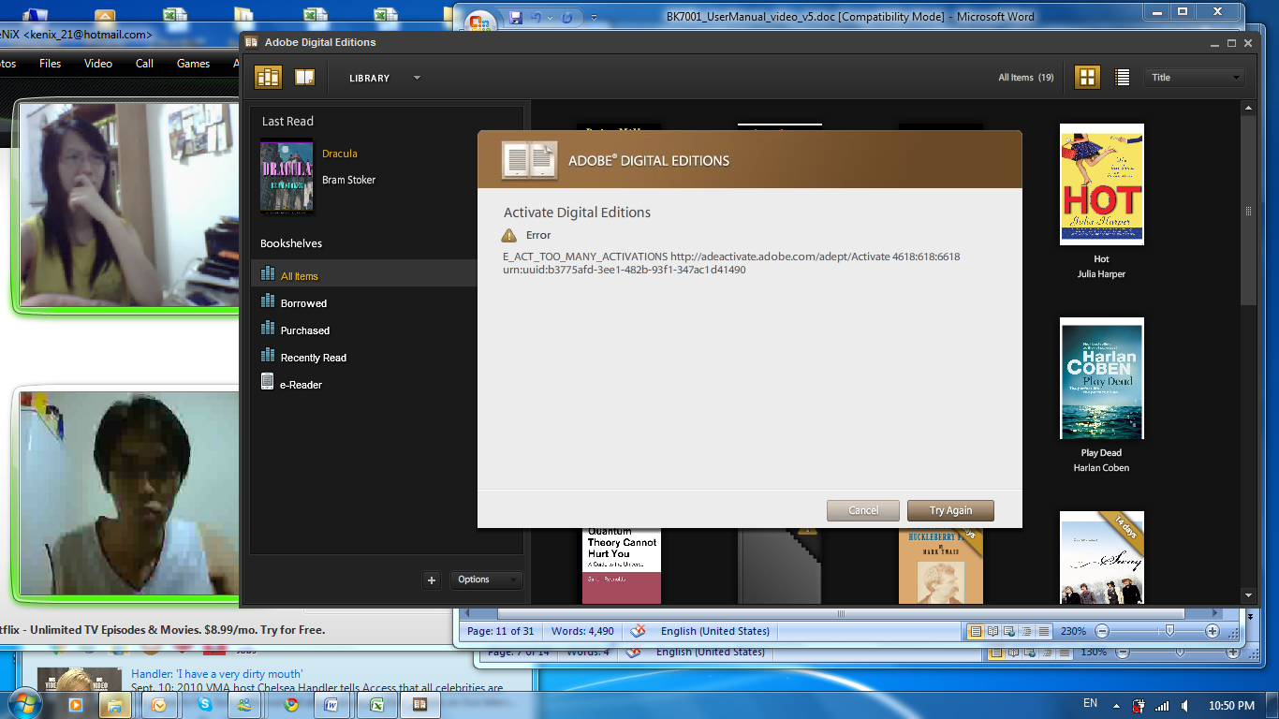
To request for extension and reset of your ADE ID, go to http://www.adobe.com/support/digitaleditions/ → [Submit a web case]. You are required to key in your ADE ID info.

Home screen
When the reader is turned on, it will enter the Home screen. Press the Return button anytime to return to the Home screen.
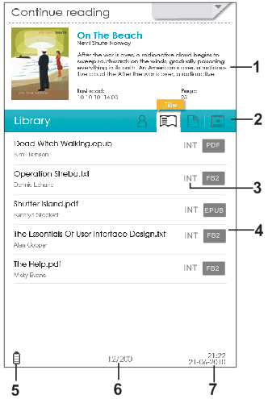 | 1.Continue Reading  -displays the page of last  read book. Tap to open the last read page.  2. Book Categories  -to sort books by different categories: Title, Author,  File Format, Date.  3. File Directory  - Indicates the location of the file.  Micro SD/SDHC –Micro SD/SDHC card  INT –Internal memory.  4. Library  -displays the list of books  available. Tap the desired book to open it.  5. Battery Indicator  -displays battery status  during operation  6. Page Number  -displays current page  Number and total available  pages.  7. Time & Date  -displays current time and  Date. You can set this from the [Settings].

Main Menu
Shows the list of available function.
- Tap on the upper right to display the Main menu.
- Tap the desired item to open.Selected item will be highlighted in grey.
- To exit from Main menu, tap on the bottom of the Main menu.
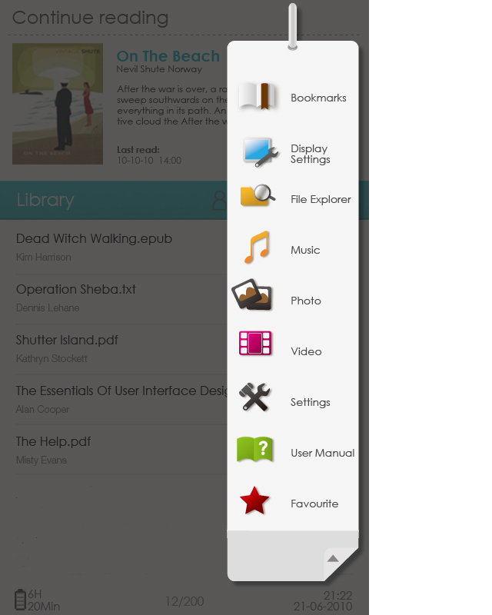


Read from previously added
Bookmarks.

Allows you configure display settings.

Enter into File Explorer for
advanced file management.


Enter into Music Player


Enter into Photo Viewer.


Enter into Video Player.

Enter into System settings.


Shows the User Manual for BK7007 ebook reader.


Open your favorite book list.

Switching Screen orientation

Via G sensor (optional)
- From Main menu, tap [Settings]→[Screen Rotate], then select [Automatic].
- Rotate the unit and the screen rotates too, automatically adjusting to fit the screen.

Manually Rotate
- From Main menu, tap [Settings]→[Screen Rotate], then select [Manual].
- Tap [Rotate] in the corresponding option menu to manually rotate.



Reading books
Swipe on the booklist or press page up/page down button to scroll the ebook list.
Supported format：TXT, PDF, EPUB, FB2, PDB.
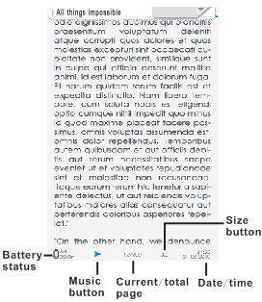

Page turning
On reading page, flick on the left/right side or press page up/down button to turn to previous/next page.

Go to Page
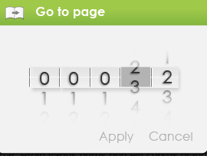
You can jump to pages by taping on the page indicator.
Input page number by onscreen keyboard. Tap [Apply] to apply settings.

Using Option Menu in Reading
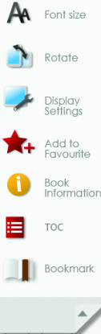
In Reading page, tap to display the title bar, then tap to enter Option Menu. Options available:

1. Font size
2. Rotate
3. Display Settings
4. Add to Favorite
5. Book Information
6. TOC
7. Bookmark

Adjusting Font Size
- In reading page, tap size button at the bottom of the page or select Font size from option menu to enter setting.
- There a 4 font sizes available: Medium, Large, X-Large, XX-Large.
- Tap on the desired font size to adjust the font size.
- It will take several seconds for the fonts to be resized.

Zooming In/Out
- You will need to use zooming function to enlarge images available in the ebook.
- Tap Size button at the bottom of the page or from Main menu, tap Font size and select [Enlarge]
- Zoom menu will appear.
- Tap the desired zoom level.
- In zoom mode, tap the directional icons to pan across the zoomed page.
- Page turning is disabled in zoom mode.
- Press <Return> button to exit zoom mode and return to original size and resume normal book reading functions.

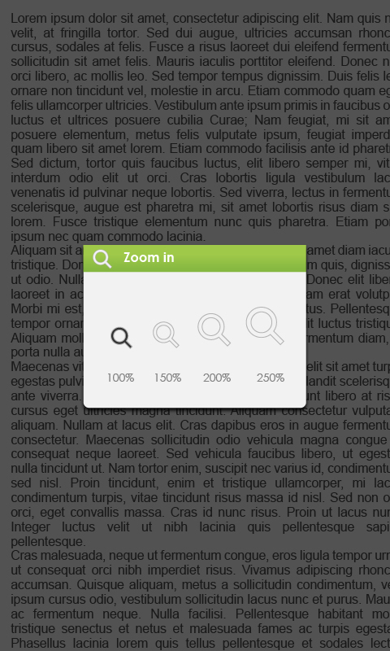

Rotate
[Rotate] allows you to rotate the display orientation.
- In landscape view, the Option Menu is divided into 2 pages. To access options in the second page, tap ▲ at the top of the Option Menu and then enter.
- To return to previous page, tap ▲ again.

Display Settings
- To adjust font color, background color, brightness during reading.

Add to Favorite
- You can add books to your Favorite List. In Option menu, tap [Add to Favorite] to add current book into Favorite List.
- To view books in Favorite List, from Main Menu, select [Favorite].
To remove book from Favorite:
- Enter Favorite List from Main menu, tap to display a deletion screen.
- Select the desired items to be deleted, then tap .

Displaying the book Information
- You can check the information of the current book from the [Book Information]. This will show Title, Author, File type, Date added, File size, Publisher and Expiration.
- Depends on the source of ebook that you download /purchase, some of the information may not be available.

Showing the Table of Contents
From Main menu, select [TOC] to show the ebook’s table of contents.

About the bookmark
Adding Bookmark
When reading, turn to the desired page, tap  to add bookmark. And the icon will turn blue.
Reading from Bookmarks in Main menu
- From Main menu, select [Bookmarks] to enter Bookmark List.
- In the Bookmark List, tap the desired bookmark to open.
Reading from Bookmarks in Current Book
- In reading page, tap and select [Bookmarks] to enter into Bookmark List.
- In Bookmark List, tap the desired page to open.
Deleting Bookmark
You can choose any of the following methods to delete bookmark.
- Turn to the bookmarked page to be deleted, then tap .
- In the Bookmark list, tap to display a deletion screen.
- Select the desired items to be deleted, then tap .

Reading books while playing music
- On reading page, tap at the bottom of the page to start reading with background music playback.
- Tap Music to enter into music playing menu during background music playing.
Note: To exit from the option menu, tap on the bottom of the menu.

Playing Music
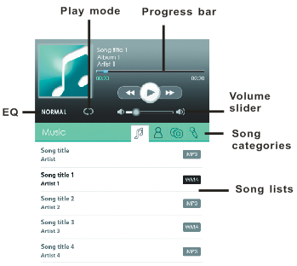
From the Main Menu, tap [Music] to enter into music player.

● In the Music player, tap / to play/pause music
playing.
● Tap / to play previous/next song.
● Touch and hold / or slide the progress bar to
Fast Rewind / Fast Forward
● Press< Vol+/-> button on the unit or drag the volume
slider to adjust volume level.
● Tap on EQ icon to set sound effect.
● Tap on Play mode icon to change play mode.
● To sort the song lists, tap on the tab from the song.
categories, the available options: title, artists, album,
genres.

Watching Videos(optional)
- From Main menu, select [Video] and enter into the video library.
- In video library, press page up/down button or drag your finger up and down on the screen to scroll the video list.
- Tap your desired video file to start playing.
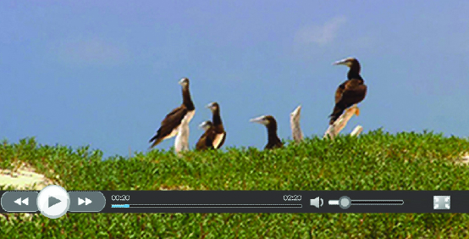
Controlling Video Playback
When playing video, tap on the screen to pop up control toolbar.
Pause or play a video | Tap /.
Go to previous/next video | Tap /.
Rewind or fast forward | Touch and hold /.
Skip to any point in a video | Tap anywhere or drag the playhead on the progress bar.
Adjust the volume level | Drag the volume slider on the the screen or use the buttons on the side of BK7007.
Adjust the screen display format | Tap .
Return to the video browser screen | Press Return button on the unit.
Notice：
- Video player supports subtitle file, please load the subtitle file to be displayed on the current video, unless the subtitle is integrated into the video itself.
- The reader supports subtitle of sub, ssa, srt, lrc format,encoded in UTF8 format.
- The file name of the subtitle must be identical to that of the video file. The subtitle will be loaded automatically during video playback.

Viewing photos
- From Main menu, select [Photo], and enter into the Photo viewer.
Thumbnail View
- All photos available in the internal memory and SD card will be listed in thumbnail view.
- In full screen mode, press the Return button to return to thumbnail view mode.
Start to view photo
In full screen mode, tap on the screen to show / hide the control bar.

start / stop slide show | Tap / .
View the previous / next photo. | Tap / or swipe on screen.
zoom in or zoom out | Tap / .
Rotate the photo by 90 degrees clockwise | Tap .
Display photo information | Tap .
Return to thumbnail mode | Tap .

Notes:
- In zoom in /out mode, tap the directional icons to move the zoomed photo.
- To return to original size, press <Return> button and resume normal operation.

File Explorer
- From Main menu, select [File Explorer].
- Tap to select Internal / Micro SD/SDHC card memory to enter.
- Drag your finger up and down to scroll through the file list.
Deleting File
- From File Explorer, tap to display a deletion screen.
- Select the desired files to be deleted, then tap .

Note: it may take longer time to delete files/folder with big file size and quantity.
These setting items allow you to customize BK7007, set the date, time and enter other preferences for the unit.

Language
To set system language for the reader.

Restore Defaults
To restore the Reader’s settings to defaults.
All settings will be restored. All DRM contents and activation will be deleted. You are required to authorize the reader again through ADE after system restored.

Date & Time
To set the clock and date, time zone, daylight saving time
- Tap on the desired item, then flick up/down to adjust the desired value.
- Press Apply button to confirm, press Cancel button to cancel the setting.
Note: Time zone setting is needed to calculate the expiry duration for book borrowing / returning.

Display Settings
To set the display brightness for the reader.

Device Standby
- To enable / disable auto standby mode, also set the time for the auto standby mode
- Press <Power> button to manually set the reader to standby mode.Press <Power> button once to wake up the reader from standby mode.

About Product
Displays product information about the reader, such as Manufacturer, Model No., Firmware version and so on.

Power Management
Displays real time battery status of the Reader.

Calibrate Touch Screen
Allow you to do touch screen calibration. Use your finger to carefully press and hold on the center of target briefly. Repeat as the target around the screen to calibrate touch screen.

Screen Rotate
To enable or disable display Screen Rotate mode.

Vibration (optional)
To enable or disable vibration mode for the reader.
The Reader is not responding or can’t be turned on.
- Reset the reader by press and hold the power button for 6 seconds. The reader will be forced shutdown if it is on and you are required to restart the reader again.
- Battery has been fully depleted. Please charge the reader via USB or USB AC Adapter.
Battery Life seems short
- The operating temperature is below 5ºC. this is due to the characteristics of battery and not a malfunction
- The battery is not used for prolonged period. Please recharge the battery of the reader again
- The battery is not fully charged. Please charge the reader for 4 hours.
- The battery needs to be replaced. Please consult the authorized dealer for service.
A Book cannot be read
- Copyright protected books cannot be read on any device other than the authorized one.
- Check if the book has expired.
- Check if the book format is supported by the reader.
The reader cannot be operated during USB connection
- The reader cannot be operated while it is connected to PC.
- Eject the reader from computer to resume operation.
- To use the reader while charging, click on the [Safely Remove Hardware] icon located on the left lower corner to disconnect data connection with computer. After the reader is safely removed, computer will only charge the reader and you can now resume normal operation.

Maintenance
- If reader does get wet, turn off reader immediately. Wait for reader to dry completely before turning on again.
- Clean the screen with a soft cloth; be careful not to wipe it with anything abrasive. When carrying your reader in bag, keep reader in the protecting case supplied to avoid scratches.
- If reader needs service, please consult the authorized dealer through the contact information provided in the warranty card. Faulty service may void the warranty.

Product Specifications
Display
7 inch TFT LCD Display, 800x480 pixels
Brightness: 200cd/m²
Storage memory
Built in memory: xxx GB (FAT format)
Supports Micro SD/SDHC card up to 16GB (FAT32 format)
Media File Format supported
Ebook: epub, pdf, txt, fb2,pdb,chm
Audio: mp3, wma, wav, ogg, aac,flac
Photo: jpg, bmp, gif,png
Video: mpeg 1, mpeg 2, mpeg 4, xvid, divx, h.263, h.264, wmv9/vc-1,rmvb, up to HD 1080p resolution
Connectivity
Data transfer: USB 2.0 High Speed
Audio: 3.5mm audio jack
Power: DC jack, USB jack

Miscellaneous
Built in speaker
Clock / Date
Real time battery indication
Battery life
Reading – up to 6 hours
Music – up to 30 hours (with backlight off)
Charging
Power supply: 5.0V, 1.2A
Duration: 6 hours (approx)
Minimum system requirement (USB Mass Storage)
Windows 2K, XP, Vista, Win 7, Linux, Mac OS 10x and above
Physical properties
Dimension: 202.8 x 124.7 x 12.8 mm (approx)
Weight: 280g (approx)

※ Optional Features are not available in all models unless specified.

※ Design and specifications are subject to change without prior notice

Certification information

On FCC
This equipment has been tested and found to comply with limits for a Class B digital device, pursuant to Part 15 of the FCC rules. These limits are designed to provide reasonable protection against harmful interference in
residential installations. This equipment generates, uses, and can radiate radio frequency energy, and if not installed and used in accordance with the instructions, may cause harmful interference to radio communications. However, there is no guarantee that interference will not occur in a particular installation.
If this equipment does cause harmful interference to radio or
television reception, which can be determined by turning the equipment off and on, the user is encouraged to try to correct the interference by one or more of the following measures:
- Reorient or relocate the receiving antenna.
- Increase the separation between the equipment and receiver.
- Connect the equipment into an outlet on a circuit different from that to which the receiver is connected.
- Consult the dealer or an experienced radio/TV technician for help.
WARNING: THE MANUFACTURER IS NOT RESPONSIBLE FOR ANY RADIO OR TV INTERFERENCE CAUSED BY
UNAUTHORIZED MODIFICATIONS TO THE DEVICE. ANY SUCH MODIFICATIONS COULD VOID THE USER'S AUTHORITY TO OPERATE THE EQUIPMENT.

On CE
The symbol means that the unit complies with European safety and electrical interference directives.

Copyrights and Trademark Notice
Copyright laws prohibit copying the data of this product or the contents of this manual (illustrations, related documents, etc.) in whole or in part without the permission of the copyright holder. Additionally, use of the data of this product or the contents of this manual is not allowed without vendor’s permission except for personal use.

Microsoft, Windows, Windows Vista and Windows Media are trademarks or registered trademarks of Microsoft Corporation in the United States and / or other countries.

Macintosh and Mac OS are trademarks of Apple Inc., registered in the U.S. and other countries.

Adobe, the Adobe logo, Reader and PDF are either registered trademarks or trademarks of Adobe Systems Incorporated in the United States and/or other countries.

MPEG Layer-3 audio coding technology and patents licensed from Fraunhofer IIS and Thomson.

The Reader contains Adobe® Reader® Mobile software under license from Adobe Systems Incorporated, Copyright © 1995-2009 Adobe Systems Incorporated. All rights reserved. Adobe and Reader are trademarks of Adobe Systems Incorporated.

Disposal and Recycling Information
Your Reader must be disposed of properly according to local laws and regulations.
Because this product contains a battery, the product must be disposed of separately from household waste. When your eBook reader reaches its end of life, contact your local authorities to learn about recycling options.

Battery Replacement:
The rechargeable battery in it should be replaced only by an authorized service provider.

This symbol on the product or in the instruction means that your electrical or electric equipment should be disposed at the end of its life separately from your household waste. There are separate collection systems for recycling in the EU,For more information, please contact the local authority or your retailer where you purchased the product.

Disclaimer
All the information, design and specifications contained in this manual were correct at the time of publication. However, as the product is under continuously upgrading, the final device may have a slightly difference in appearance or modified functionality than presented in this manual.


Contains Reader® Mobile technology by Adobe Systems Incorporated

