
Beauty Making up game. Make your own avatars. You can choose your hair style, eye shadow and lips color here.

→←↑↓★
↑ and ↓ -- Select items
★ button -- Confirm
button -- Back


Fashion Design Dressing game. Stylish clothing and lots of jewels and accessories are waiting for you.

↑ and ↓ --- Select items
← and → — Zoom in and zoom out.
★ button -- Confirm
button -- Back

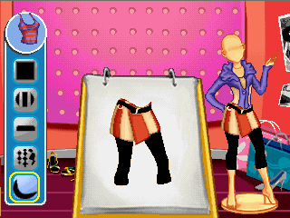
Design Room Designing game. Be a fashion designer! You can design the stripe style and color of new costumes here.

↑ and ↓ -- Select items
★ button -- Confirm
button -- Back

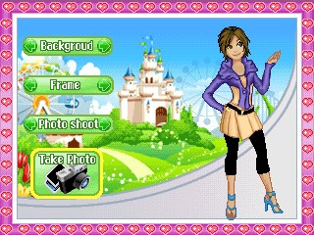
Photo Studio You can take photos here in sorts of scenes and frames and with all kinds of costumes you design for the girls.

↑,↓, ← and → -- Select items
★ button -- Confirm
button -- Back

Photo
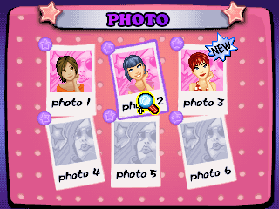
This is an album，you can check the photos taken in Photo Studio

↑,↓, ← and → -- Select photos.
★ button -- Confirm
button -- Back

GAME ZONE
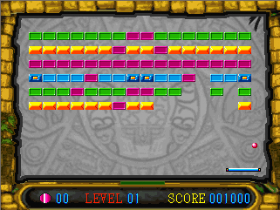
Bump Jump Using the pad below to receive the ball and clashes with the bricks above.

Directional Joystick: Left and Right
★Button: Shooting

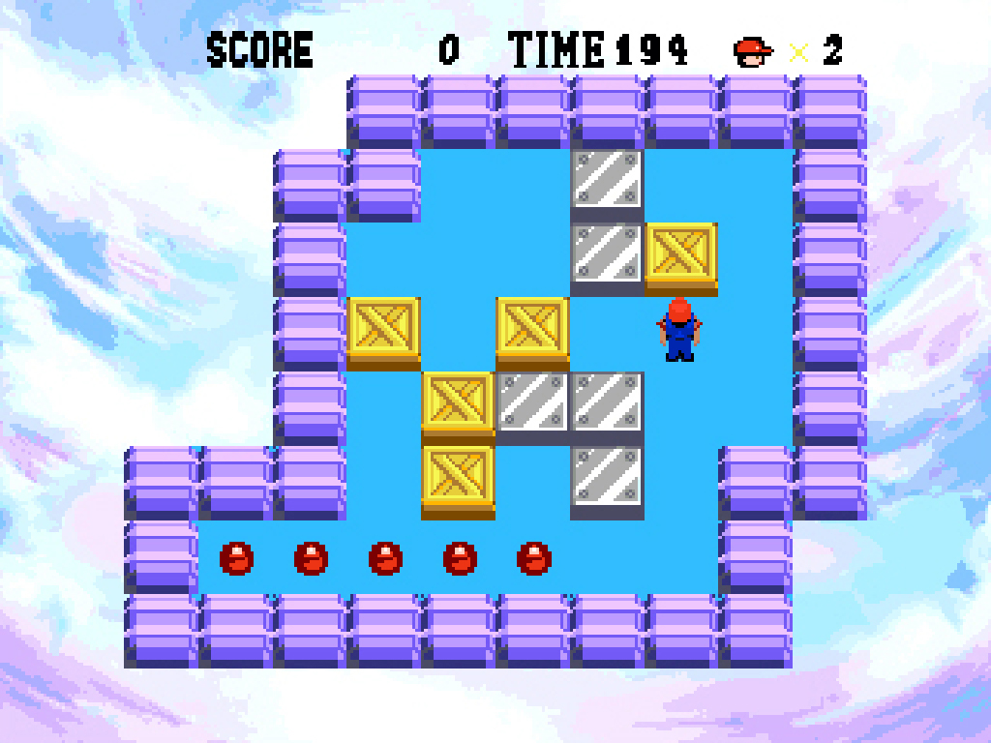
Busy Bong This is a puzzle solving game. You must reach the box in each puzzle room in the limited time. Move the crates to get to your destination.

Directional Joystick: 4 directions

★ Button: Undo one step
Button: Try again or not?

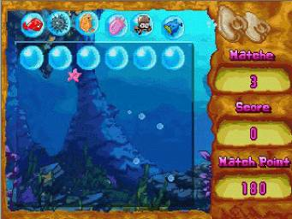
Find Pairs This child mate game is a funny memory game. Turn over the cards in the game area, when the same patterns showing, they are disappear.

Directional Joystick: 8 directions
★ Button: Confirm the selection

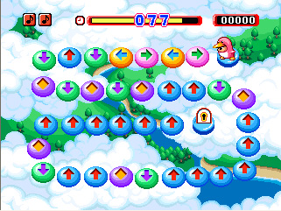
Finger Dancing According to the direction of the arrowhead to input the commands. If not to input all of the commands at against time, the game is over.

Directional Joystick: 4 directions

★ Button: 游戏图标输入功能

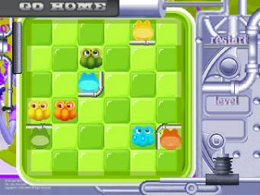
Go Home Move each role to the corresponding place, all of the roles are the right place, you will enter the next level.

Directional Joystick: 4 directions
★ Button: Confirm the selection
Button: Confirm to restart or not

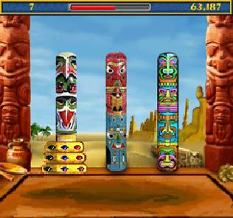
Hanoi Tower The dishes put on the column from the bottom up according the size from big to small. Move the dishes on the first column to the appointed column. During move it, must keep the dishes arrange big to small from the bottom up.

Directional Joystick: Left and Right
★ Button: Select the dish

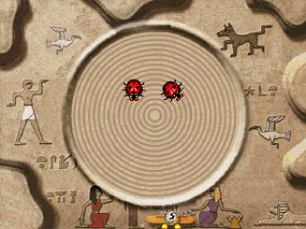
Bump Bomb The insects on the screen are moving, press the key to let them together, then they will disappear, there is only one insect on the screen will advance the next level.

★ Button: Moving the insects

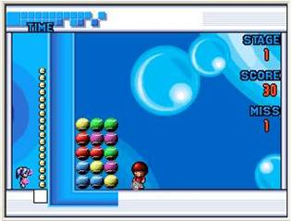
Caddie Distinguish the same objects in the limited time and move it so that any three same objects can be connected into a straight line.

Directional Joystick: 4 directions
★ Button: Knock on

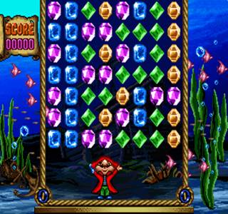
Jewel Fever In this fun puzzle game, you have to help Mr. Stubbs, the fun-loving pirate, collect games for his treasure chest. As they drop from above, scoop up gems from one area and fire them somewhere else. When they hit, any gems of the same color will be collected.

Directional Joystick: Left and Right
★ Button: Collect gems
Button: Shoot gems

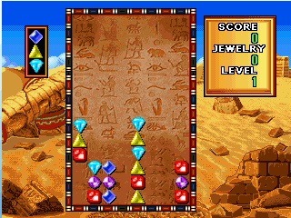
Jewel Master As the jewels fall in groups of three, try to line up jewels of the same shape and color. Try your best to wipe off all the jewels of the same color and shape.

Directional Joystick: Left and Right
★ Button: Change sequence of three jewels
Button: Put the jewels horizontal
Down direction: Accelerate

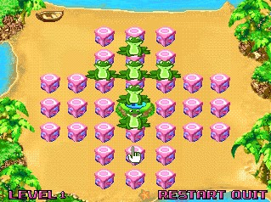
Jump Frog Select the frog, he will jump over the frog beside to him to the empty place. Then the jumping frog and the frog beside to him will disappear. Until only 1 frog left, enter the next level. The frog jump along horizontal and vertical but not jump diagonal in 45 degrees on the chessboard.

Directional Joystick: 4 directions
- Button: Select the frog

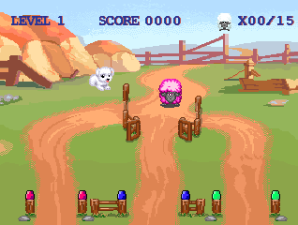
Sheep-Dog Day Control the main middle fence to direct way for all the sheep. But must make sure the color sheep enter to the right color fences. At the same time the sheep will move forward automatically in a certain speed. In order to pass to the next level, player must fulfill the specific number requirement by directing the sheep to the correct color fences correctly.

Direction joystick: Control the fence

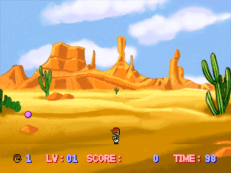
Pop Ball Control the button to emit a light column, hit the bubble to split. Hit the big bubble, it become small, hit the small bubble, it become none, when it is none, will enter the next level.

Directional Joystick: Left and Right
★ Button: Shooting

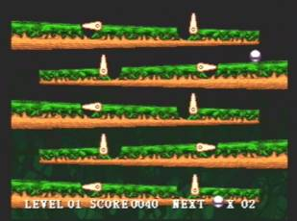
Quick Move Control the button to open or close the holes, and not let the ball drop into the hole. Then advance the next level.

★ Button: Control the switch

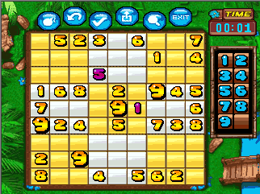
Number Quze The game rule is: In the 9x9 square, infilling the number 1-9 on each line and list, and can’t repeat the number. At same time, in each 3x3 square infilling the number 1-9 and can’t repeat too.

Directional Joystick: 8 directions
- Button: Confirm the selection
Button: Select the menus

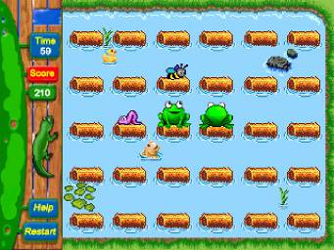
Zippy Froger Change the direction of the frog to eat all of the insects in the limited time, then you can pass the level.

Directional Joystick: 8 directions
- Button: Attack

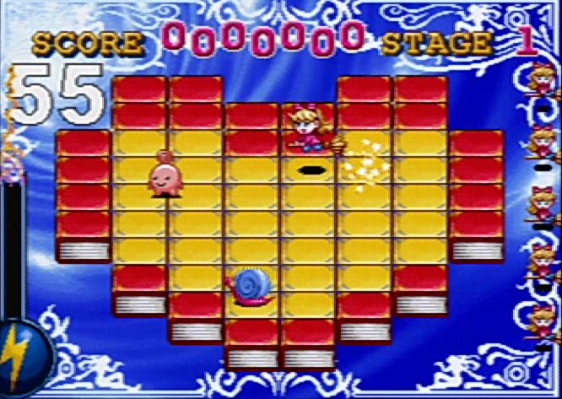
Magic Jelly Use the magic ball on the diamond, in the limited time the ball will pop. Change all of the diamonds color, dodge the enemies and the arms from the enemy. You’ll advance the next level.

Directional Joystick: 4 directions
★ Button,: Put the bomb

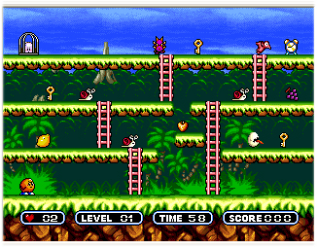
Mr. Onion Mr. Onion must collect all the keys to the next level. At the last level, he must fight with the snowman defeat the snowman to rescue his friend. Mr. Potato is going to need lots of help if he’s going to win this exciting game!

Directional Joystick: 4 directions
- Button: Shooting

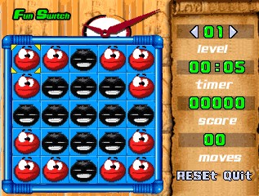
On N off Select the bright or dark lamp, if the lamp selected is bright, then the other lamps round of it will turn dark, in reverse if the selected lamp is dark, then the lamps round it will be bright. When all of the lamps turn dark, then finish the game.

Directional Joystick: 4directions

★ Button: Confirm the selection
Button: Return the Menu

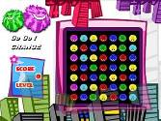
Super Move Quest There are several types of objects displayed on the screen. Move them so that any three or more of the same objects are connected in a straight line.

Directional Joystick, Pad: Move cursor

★ Button : Confirm the selection

Bubble Blaster Balls of different color move along the track toward the player. If a ball strikes the player, the game is over. To stay alive, the player must remove balls from the track. Arrange them so three or more of the same color ball connect and they’ll be removed. Watch out, as your score increases the balls will speed up!
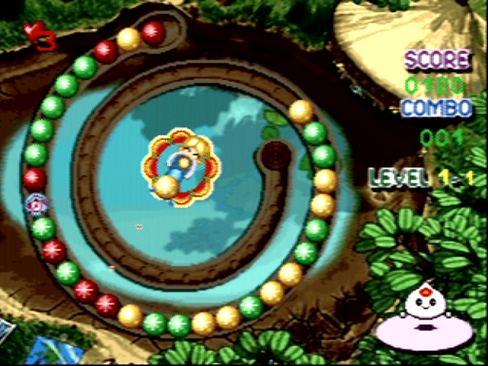
Directional Joystick, Pad: Left and Right
Steering Wheel: Left and Right
★Button : Shooting

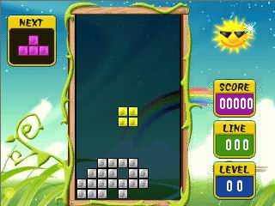
Dream Bubble Some diamonds with different style, dropping from the upper screen, you will put them together to become an intact diamond, then the diamonds on a line will disappear.

Directional Joystick, Pad: Left and Right
Steering Wheel: Left and Right

★Button : Change sequence of three jewels

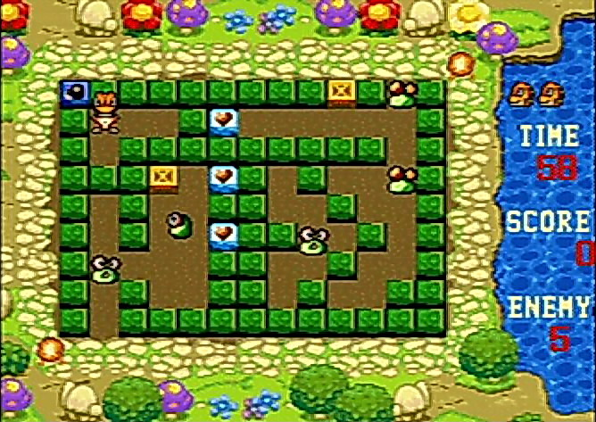
Final Escape Control the crocodile to push the bricks, When two bricks push together, they will bomb, and appear the food. When the crocodile dodge the attack from the enemies and eliminate all the enemies, it will advance the next level.

Directional Joystick, Pad: 4 directions
Steering Wheel: Left and Right

★/ Button: Push the brick

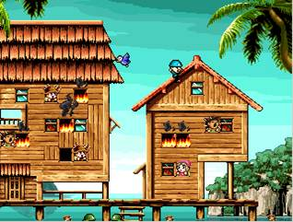
Fire Fighter Position the spring bed in order to bump the falling fire fighter. During the bumping, the fire fighter can put out the fire in the burning room. If the person asks for help in the burning room, you can save him by positioning the spring bed. If fire is stumped out or all the men are saved, you will advance to the next level.

Directional Joystick, Pad: Left and Right
Steering Wheel: Left and Right
★Button: Jumping

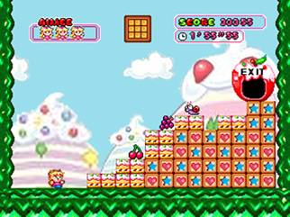
Yummy Control the diamond dropped from the upper. Build the diamonds to a stairway, to help the actor get to the EXIT to escape from the dangerous.

Directional Joystick, Pad: 3 directions
Steering Wheel: Left and Right

★/ Button: Change the angle of the diamond

